* PostgreSQL is a powerful, open-source object-relational database system.

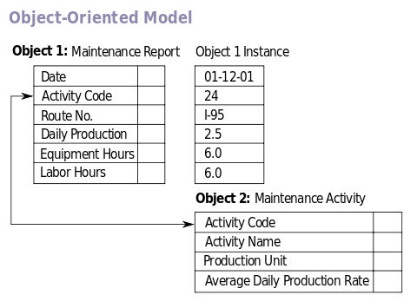

* It has more than 15 years of active development phase and a proven architecture that has earned it a strong reputation for reliability, data integrity, and correctness.